Solve : Using latest Java 8 API

1.Create int[] ---> IntStream & display its contents.

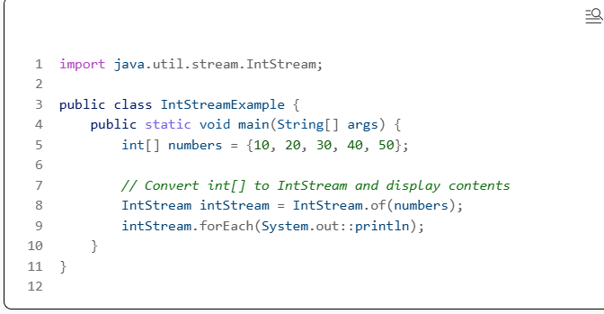

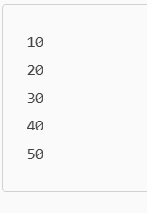

2. Create AL<Integer> , populate it.

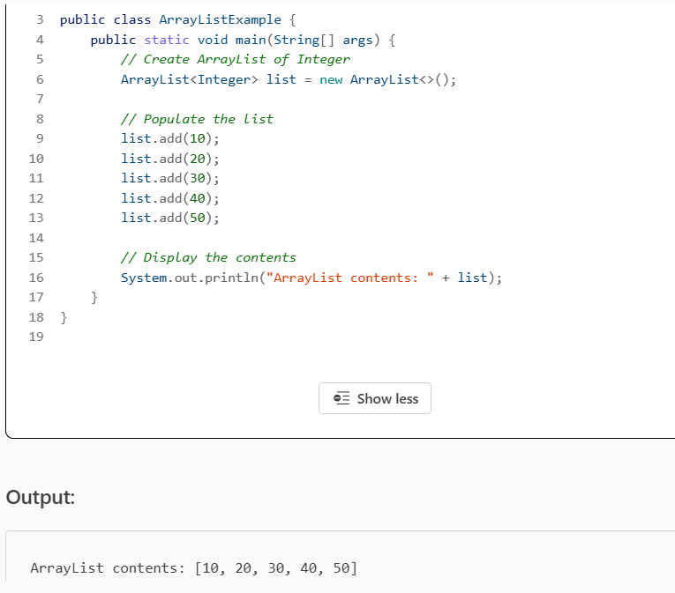
Convert it to seq stream & display elements
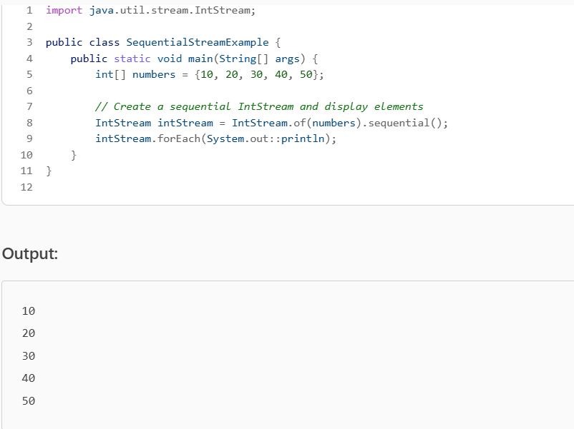

Convert it to parallel stream & display elements

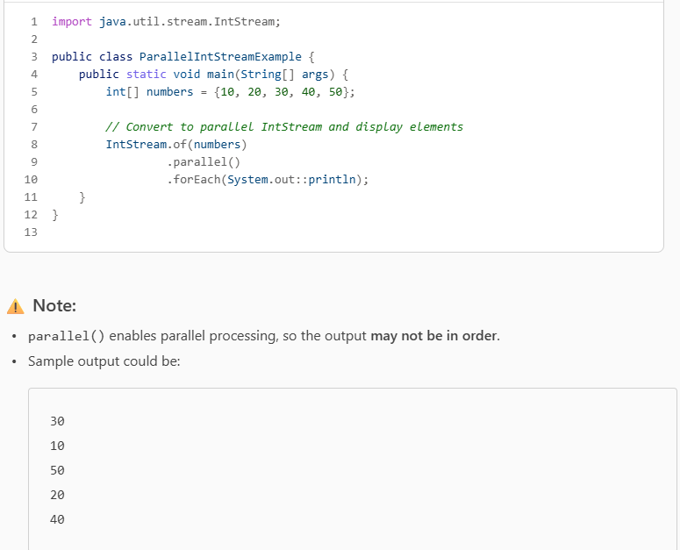

3. Create stream of ints between the range supplied by user & display all multiples of 3
(Hint : IntStream methods --range,filter,forEach)

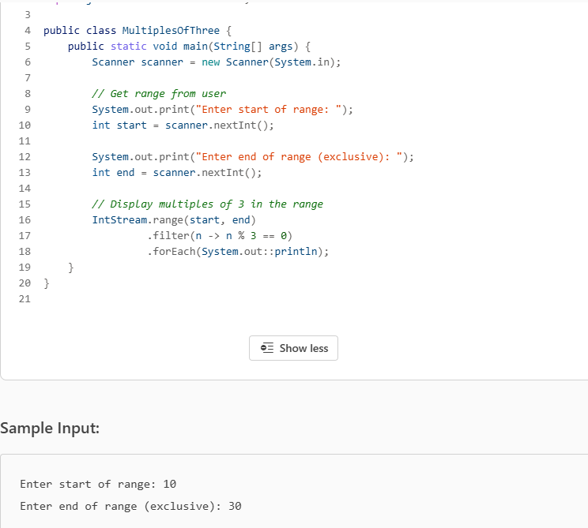

4. Display all product names of a particular category , exceeding specific price.
I/P category name & price.
(stream,filter,forEach)

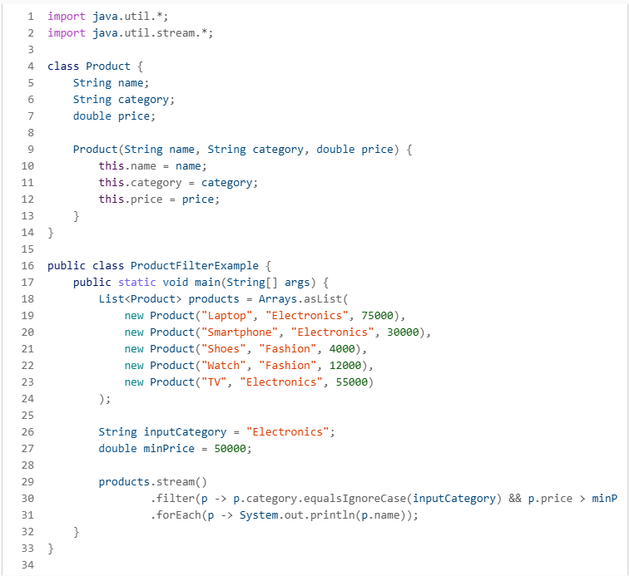

Ans)
Laptop
TV

5.Create IntStream having ints in the range of 10...50
& Print its sum.(specialized reduction operation)
Hint( rangeClosed , sum)

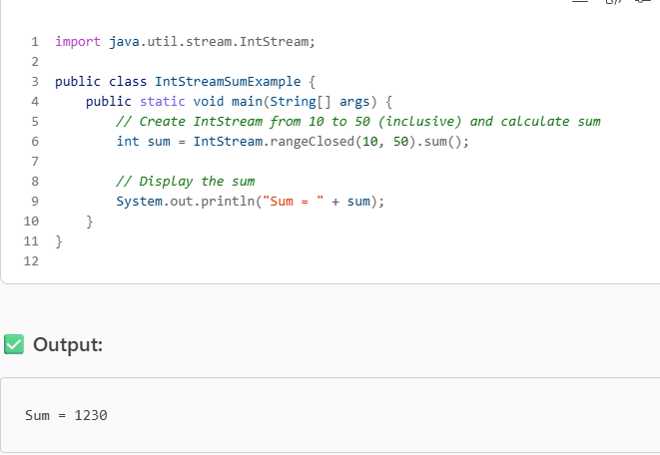

6.Print avg of 10-50 numbers(if strm is empty print -100 or else print avg)
(rangeClosed,average & optional)

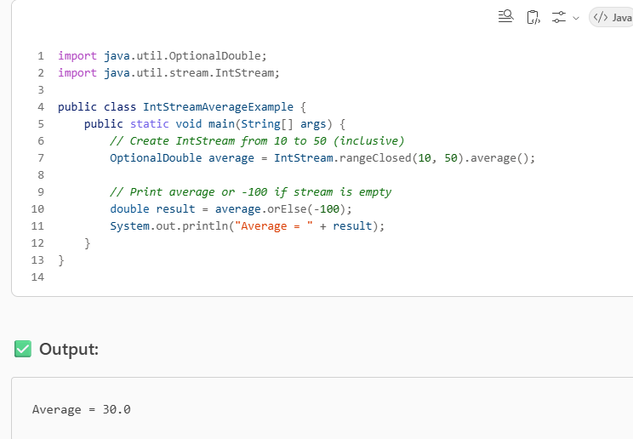

7.Print avg of square of odd nums between 10 & 50
(filter,map,reduce)

